The following amendments are required to bring the website into compliance with the applicable requirements.
1. Sora AI Model — We were unable to generate a video using Sora. The Sora video generation model must be removed or replaced with an alternative, as well as OpenAI has discontinued the Sora video generation service. (https://help.openai.com/en/articles/20001152-what-to-know-about-the-sora-discontinuation)
2. Blog Section — The blog page exists, and all posts link to articles on Medium. The Blog page must be removed from the website. A link to the Medium profile must be added to the footer instead.
3. Email Domain — Transactional emails, including account confirmation messages, must be sent from the website's own domain rather than from noreply@reelzila.firebaseapp.com.
4. Password Reset Page — The password reset flow must be fixed. Currently, following the reset link from the email results in a 404 error, which must be resolved.
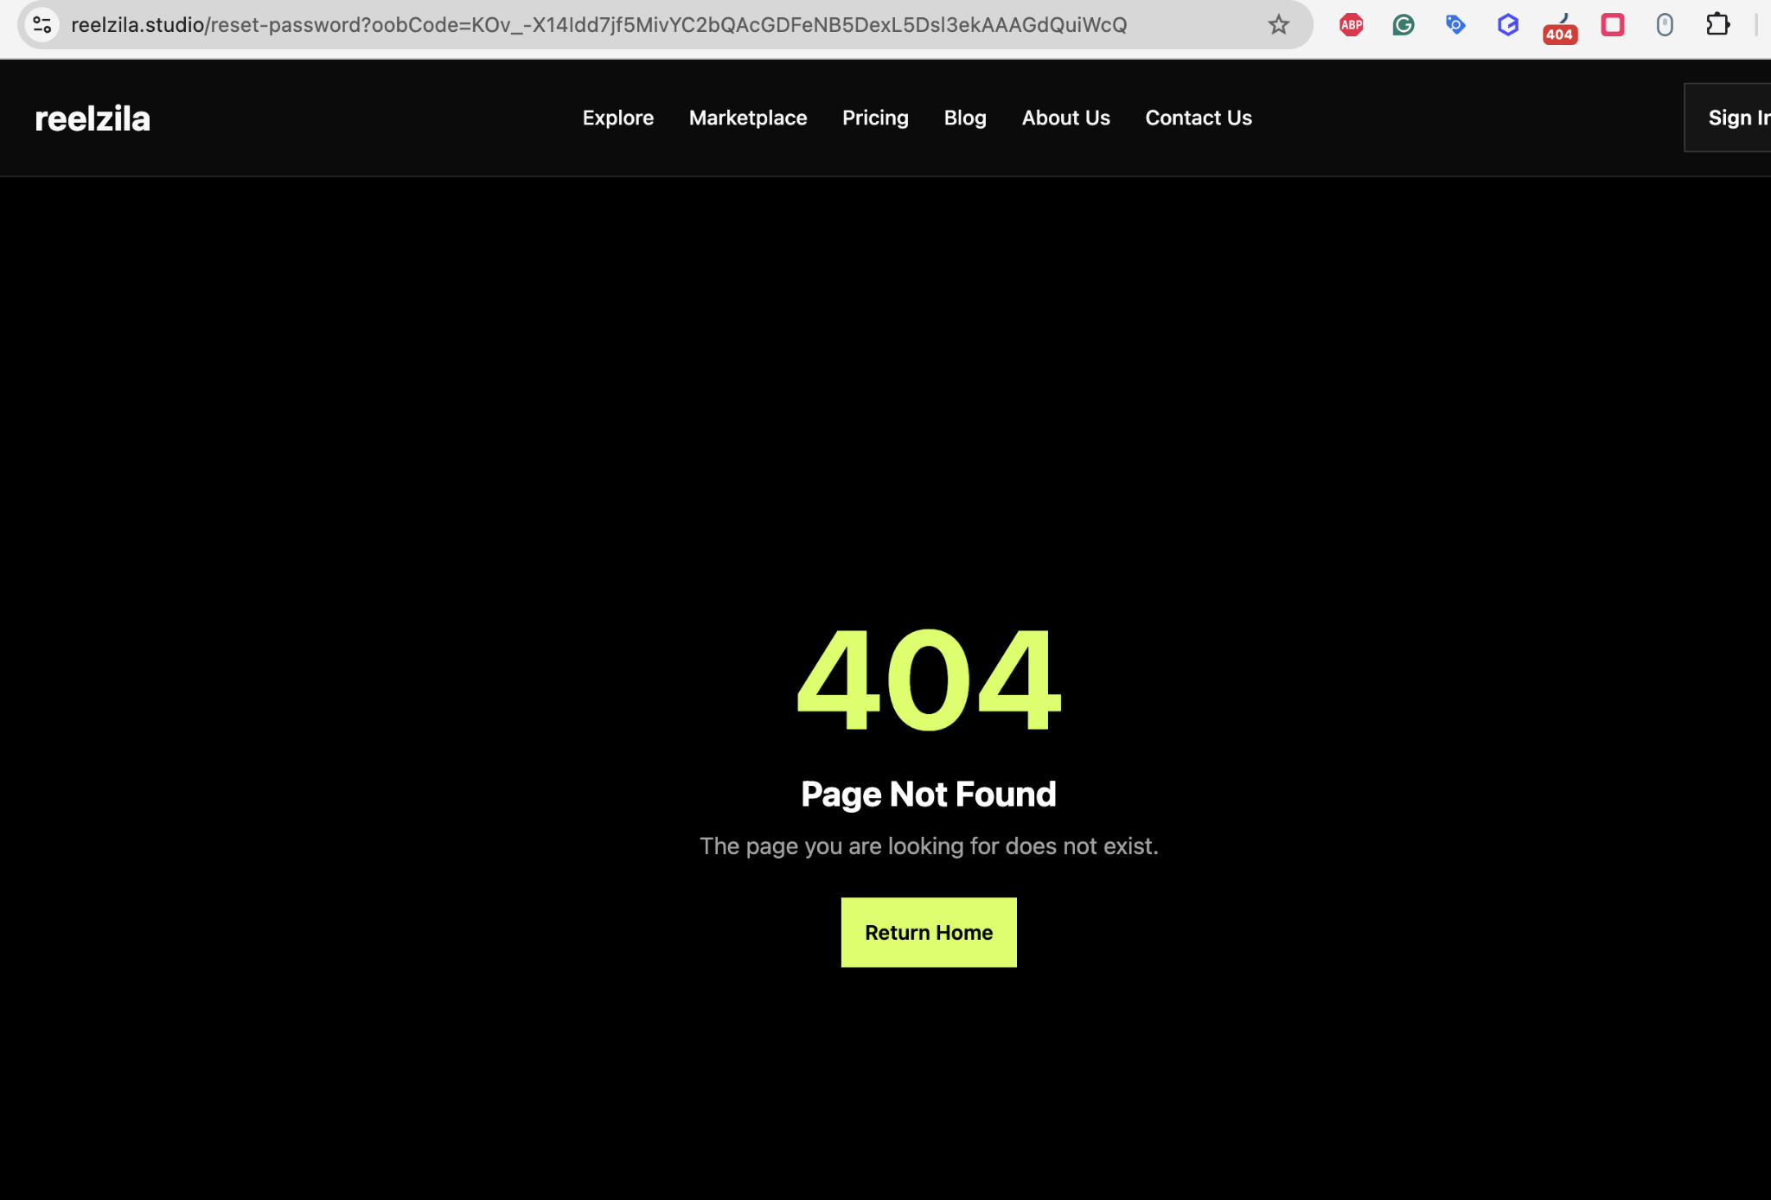
Social Media Links — All social media links must be removed from the website. For now. To be added later.
Custom Amount Input — Users must be able to manually enter a custom payment amount. The current slider-only input is insufficient and must be supplemented with a free-text input field.
Mobile Responsiveness — On model pages, page headings overflow beyond the screen width on mobile devices and must be corrected to display within the viewport.
